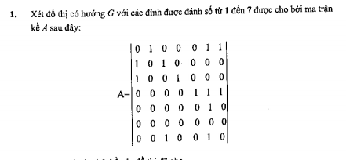
Danh sách kề
v | Adj(v)
1 | 6,7
2 | 1,3
3 | 1,4
4 | 5,7,7
5 | 6
6
7 | 6,3

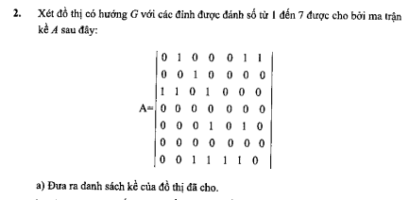

v | Adj(v)
1 | 2,6,7
2 | 3
3 | 1,2,4
4
5 | 4,6
6
7 | 3,4,5,6

Bài 7:
Bước lặp | A |  |  | B |  |  | C |  |  | D |  |  | E |  |  | F
Bước lặp | d | p | k | d | p | k | d | p | k | d | p | k | d | p | k | d | p | k
Khởi tạo | 0 | _ | F | vc | _ | F | vc | _ | F | vc | _ | F | vc | _ | F | vc | _ | F
1 | 0 | _ | T | 6 | A | F | 5 | A | F | vc | _ | F | vc | _ | F | vc | _ | F
2 |  |  |  | 6 | A | T | 5 | A | T | 7 | C | F | 9 | B | F | 8 | B | F
3 |  |  |  |  |  |  |  |  |  | 7 | C | T | 9 | B | T | 8 | B | T

